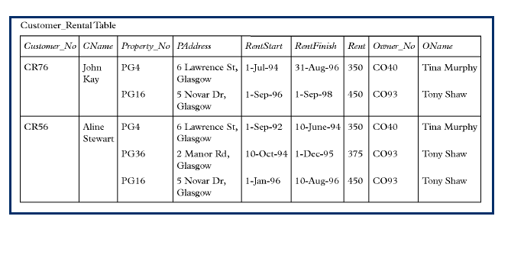
1st Normalization, we should make a separate tables for properties and its addresses, dates, rents, owners and so on.
- Customer_No, CName
- Owner_No, Property_No, Customer_No , PAddress, RentStart, RentFinish, Rent, OName

2nd Normalizatoin, we should assign keys to its related primary keys.
- Customer_No, CName (Customers)
- Owner_No, OName (Owners)
- Property_No, Owner_No (FK), Paddress (Properties)
- Customer_No (FK), Property_No (FK), RentStart, RentFinish, Rent (Rents)
Note: I didn’t put the Owner_No in the fourth table, as we can know the owner from the Property_No. As a result, modifications operations are reduced, as if the owner is changed in the third table, There is no need to change it in the fourth table.

3rd Normalization. I guess that there is no transitives in our current structure, so the tables will be as it is the 2nd Normalization.

